**Lab 9: Dynamic Routing Configuration Using**

**Border Gateway Protocol (BGP)**

**Objectives:**

The primary objective of this lab was to understand the basic principles of BGP and its operational mechanisms in network communication. We aimed to configure BGP routing tables and explore how the protocol selects the best paths for data transmission between different Autonomous Systems. Another objective was to analyze BGP's handling of changes in network topology and its ability to maintain stability. Additionally, we sought to investigate the potential security risks and challenges related to BGP misconfigurations. Lastly, we aimed to apply troubleshooting techniques to resolve common BGP routing issues.

**Aim:**

**To do the following:**

* To set the hostname of each router to "rajan" and ensure that the labeling on the network configuration is properly done.
* To configure IP addresses on each router interface and establish dynamic routing using BGP.
* To verify network connectivity using ping tests between all routers.

**Dynamic Routing:**

Dynamic routing is a method where routers automatically adjust their routing tables based on changes in the network. It eliminates the need for manual updates by allowing routers to exchange routing information in real-time. This adaptability makes dynamic routing ideal for networks with frequently changing topologies, such as large enterprise environments or WANs. It improves network efficiency by automatically finding the best available path for data transmission. Dynamic routing protocols, like RIP, OSPF, and EIGRP, ensure that the network remains operational even when links go down or new routes are introduced.

**Border Gateway Protocol (BGP):**

Border Gateway Protocol (BGP) is the standardized exterior gateway protocol used to exchange routing information between different autonomous systems (Autonomous Systems) on the internet. It plays a crucial role in determining the best paths for data to travel across vast and diverse networks. BGP operates based on policies and rules defined by network administrators, allowing for flexibility in route selection based on factors such as path attributes, administrative preferences, and network performance. One of BGP's key features is its ability to maintain a stable connection even as the internet's topology changes, making it highly resilient. However, BGP is also complex and can be vulnerable to misconfigurations or malicious attacks, which can lead to routing issues or security risks.

**Simulating Dynamic Routing in Cisco Packet Tracer:**

**Step 1: Set up a network with some end-devices with switches and routers.**

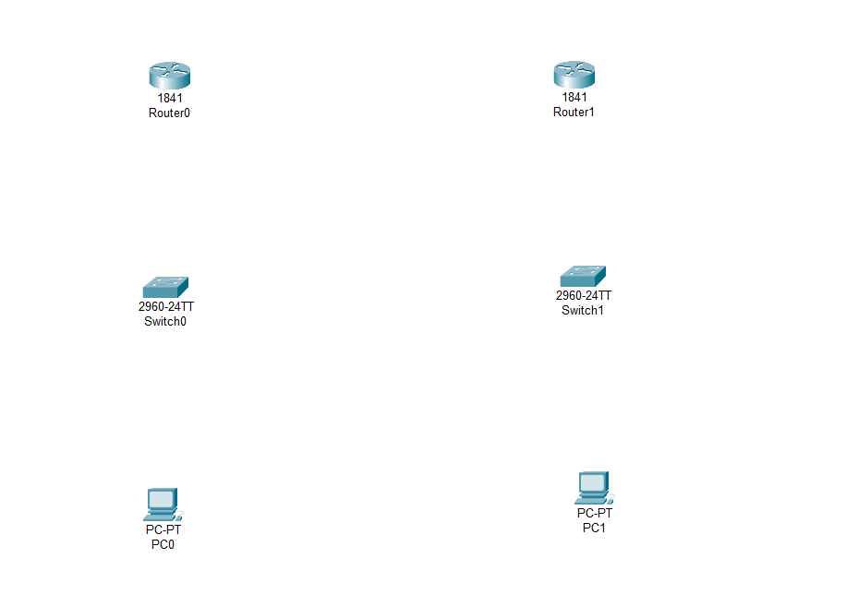

**Step 2: Connect the PCs to the switch and connect switch to routers. Before connecting the routers add the serial port WIC-2T to the routers and turn off the router before adding serial port.**

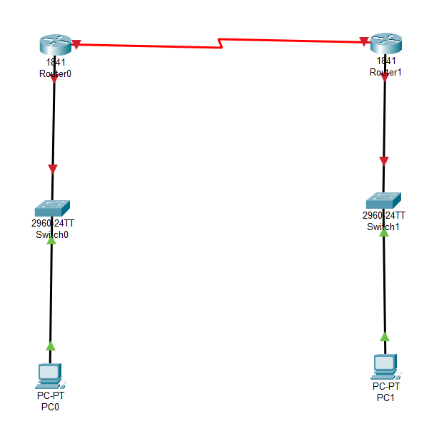

**Step 3: Provide an IP address to each PCs and routers.**

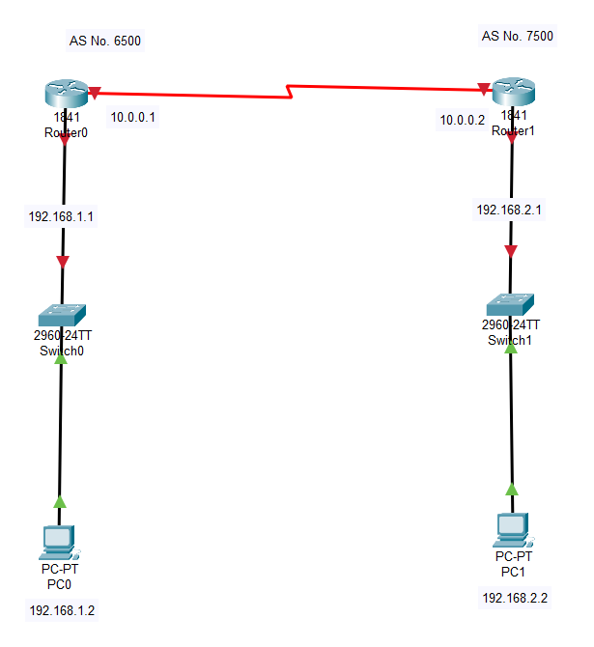

**Step 4: Configure the IP addresses for the routes.**

**Router 0:**

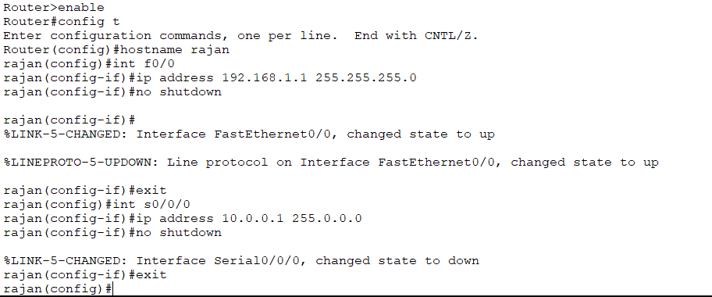

**Router 1:**

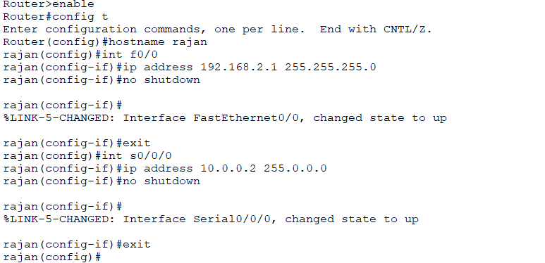

**Step 5: Now configuring the BGP routing into the routers.**

**Router 0:**

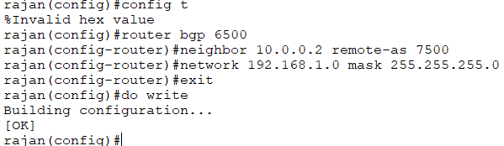

**Router 1:**

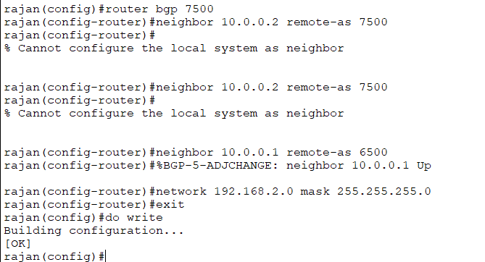

**Step 6: Send packets between computer within different PCs.**

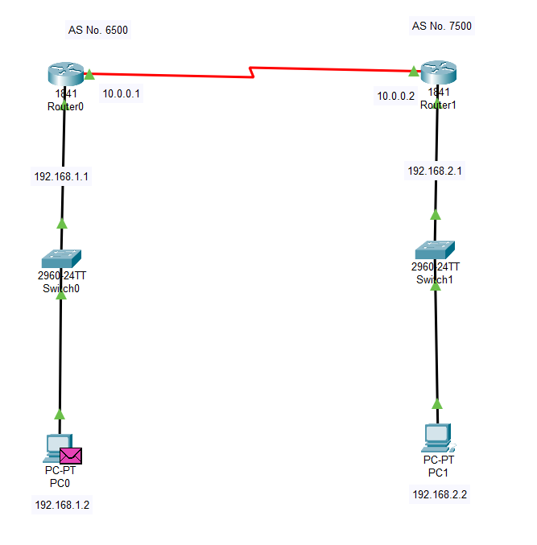

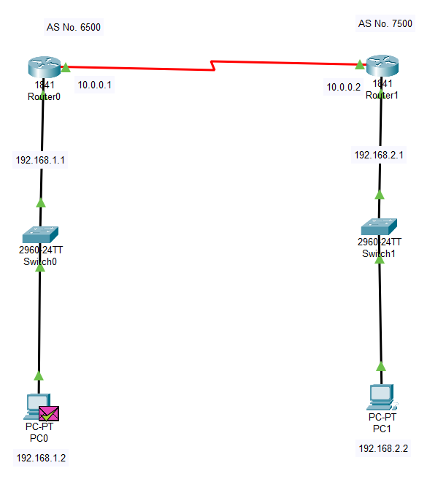

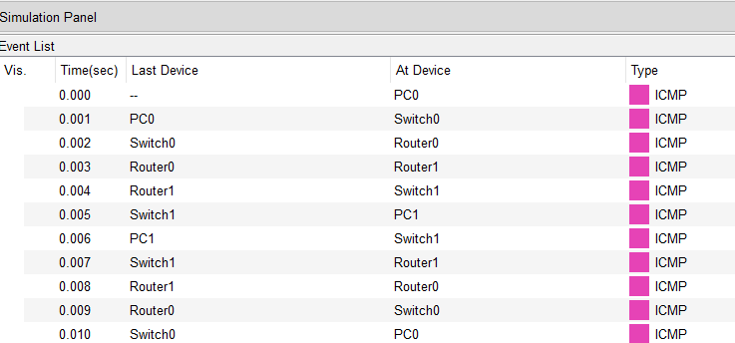



**Step 7: Ping test between PCs between different networks.**

Ping from PC0(connected to Router 0) to PC1 (connected to Router 1):

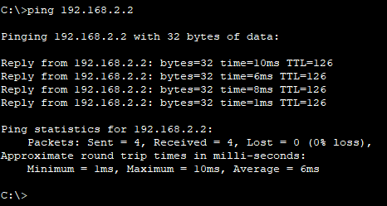

Ping from PC1(connected to Router 1) to PC0 (connected to Router 0):

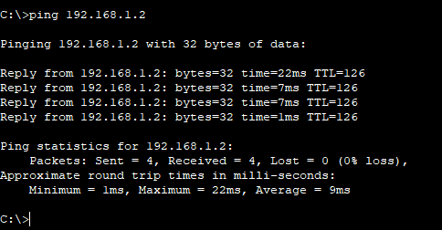

**Conclusion:**

In this lab, we explored the functionality of Border Gateway Protocol (BGP) and its role in facilitating communication between autonomous systems. The experiment demonstrated how BGP establishes routing paths based on pre-defined policies and network attributes, ensuring efficient data transmission across diverse networks. Through various configurations and simulations, we observed the protocol's resilience in maintaining connectivity even in dynamic network environments. However, we also noted the potential risks associated with BGP misconfigurations, which can lead to routing issues or security vulnerabilities. Overall, the lab provided valuable insights into the complexities and significance of BGP in global internet routing.